Bansilal Ramnath Agarwal Charitable Trust’s

Vishwakarma Institute of Information Technology

*(Department of Electronics & Telecommunication)*

Hardware implementation entitled

**"HOME AUTOMATION"**

|  |  |  |  |  |
| --- | --- | --- | --- | --- |
| **Submitted By:** | | | | |
| **Roll No.** | **Division** | **Name of Student** | **E-mail** | **Contact Number** |
| 211069 | A | Devesh Aasheesh Khanzode | Deveshkhanzode@gmail.com | 8788003997 |
| 211065 | A | Pranali pravin sonawane | pranalisonawane050@gmail.com | 9156982822 |

For the course

**Skill Development (Electronic Workshop Practice– I)**

**S.Y. B. Tech**

*Under supervision of*

**MR. PRAVIN G. GAWANDE**

*Year 2018 – 2019*

**Course Objectives:**

* To make the student familiar with electronic components.
* To imbibe good soldering design practices for robust design of electronic systems.
* To highlight the importance and teach PCB artwork with an EDA tool.
* To orient the students towards hardware implementation.

**INDEX**

|  |  |  |  |
| --- | --- | --- | --- |
| **Sr. No.** | **Contents** | | **Page No.** |
| 1. | Abstract | | 1 |
| 2. | Electronic Component list and specifications | | 2 |
| 3. | EDA tool used for schematic and PCB design | | 3 |
| 4. | Circuit diagram implementation using EDA tool | | 4 |
| 5. | Implementation of PCB using EDA tool | | 5 |
|  | 5.1. | Rules specified for PCB design | 5 |
|  | 5.2. | Top layer ( image of component layer) | 6 |
|  | 5.3. | Bottom layer ( Image of Copper layer) | 7 |
|  | 5.4. | 3D view | 8 |
|  | 5.5. | PCB Information | 9 |
| 6. | PCB Development Process | | 10 |
|  | 6.1. | PCB Etching | 10 |
|  | 6.2. | PCB Cleaning | 11 |
|  | 6.3. | PCB Drilling | 12 |
| 7. | Verification of PCB (Track Continuity checking) | | 13 |
| 8. | Soldering techniques/Processes | | 14 |
| 9. | Troubleshooting | | 15 |
| 10. | Actual Hardware Image ( Solder side and Component side) | | 15 |
|  | 10.1 | Solder side ( Copper layer side) | 15 |
|  | 10.2 | Component side | 16 |
| 11. | Conclusion | | 17 |
|  | References | |  |

1. **Abstract:**

**This project is about Home Automation in which we are going to save energy with the help of electronic sensors and actuators.**

**As we know in day to day life due to human interference sometimes we forgot to switch off electrical appliance and large power gets wasted as well as there can be chances of accidents.**

**So that to avoid such circumstance’s we implemented this project here, we are going to sense the passage of a person into the room using IR & photodiode and then it gets counted in controller by using that data, power will be fed to the appliances.**

**Here, we have used LDR to sense the light intensity at any instant and according to intensity light in room is adjusted.**

1. **Electronic Component list and specifications**

|  |  |  |  |  |
| --- | --- | --- | --- | --- |
| **Sr. No.** | **Name of components** | **Quantity** | **Specifications/Value** | **Cost** |
| 1. | 89s52 | 1 | 8 bit microcontroller | 100/- |
| 2. | Resister | 9 | 330,10K,1K 1/4W, preset 10K, LDR | 40/- |
| 3. | Capacitor | 3 | 33p,10uF 63v | 9/- |
| 4 | LM358 | 2 | Comparator IC | 15/- |
| 5 | 7805 | 1 | Voltage regulator 5v | 9/- |
| 6 | Crystal | 1 | 11.0592MHz | 6/- |
| 7 | Photodiode | 2 |  | 8/- |
| 8 | LED | 5 | IR, RGB LED 3mm | 10/- |
| 9 | PCB fabrication |  |  | 40/- |
| 10 | Other cost |  |  | 63/- |
|  | **Total** | **31** |  | **300/-** |

1. **EDA tool used for schematic and PCB design**

The EDA tool used is Proteus.

* Proteus is an online PCB design tool. It allows you design schematic and PCB layout online. It has a very simple design interface.
* Proteus is designed with a circuit simulation tool that allows you to see your circuit in action before developing it into a board.
* It is compatible, it allows to import design from other pcb design softwares such as Eagle and Altium.

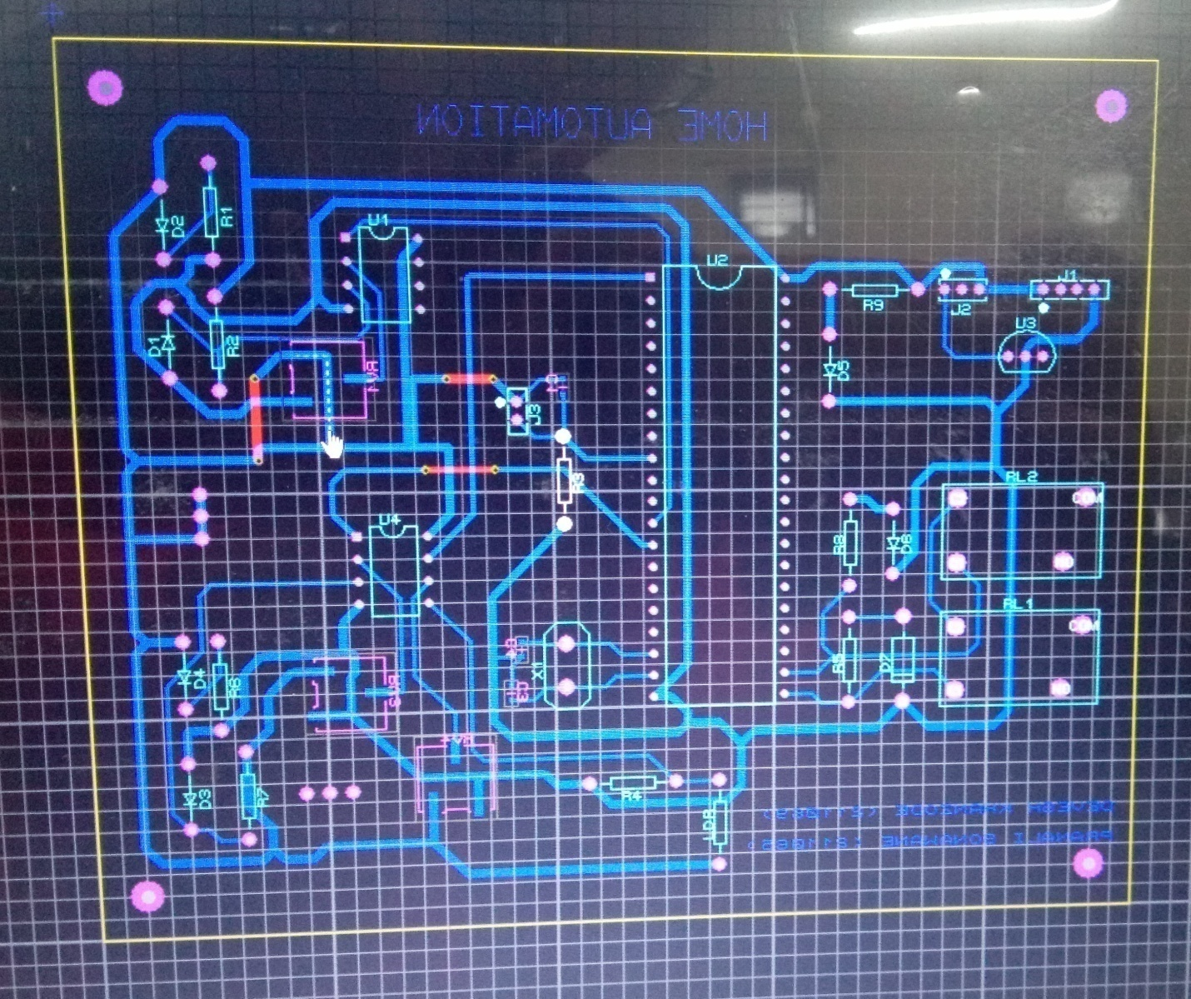

1. **Circuit diagram implementation using EDA tool**

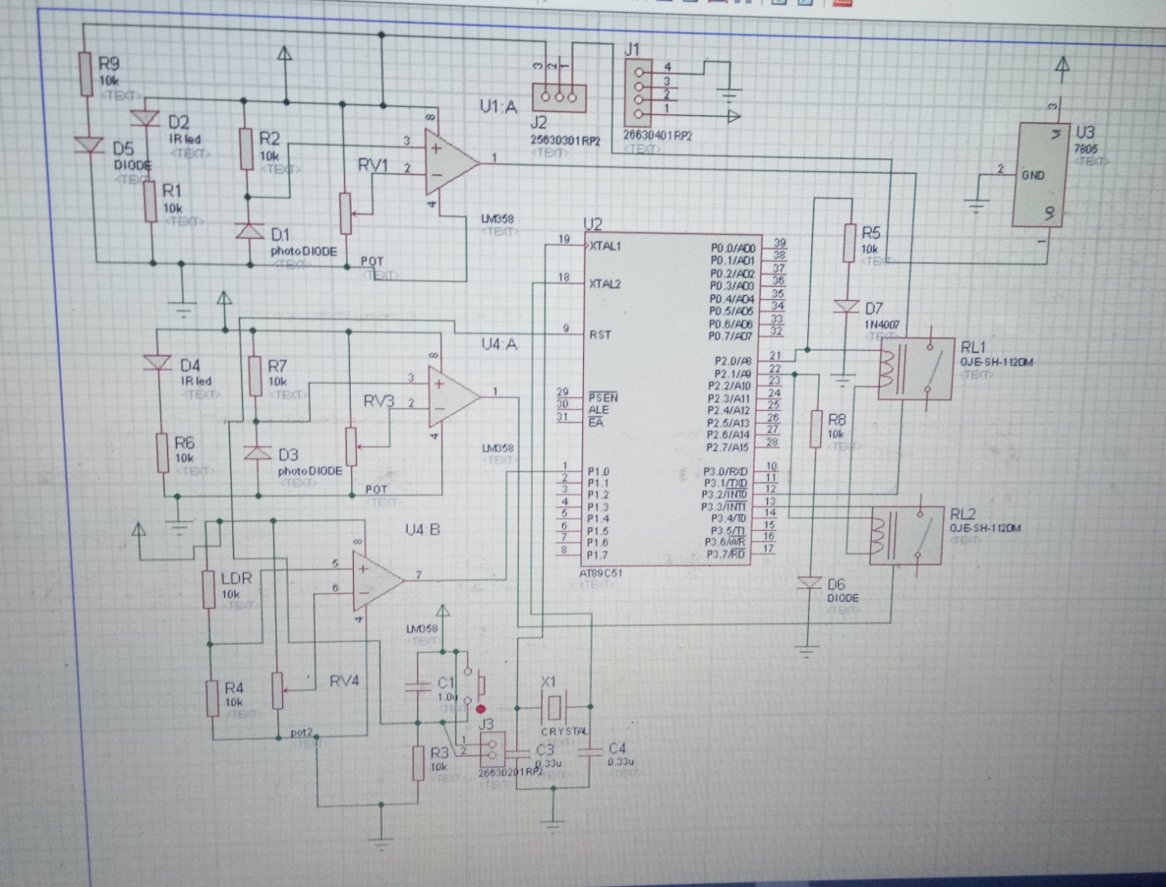

1. **Implementation of PCB using EDA tool**
   1. **Rules specified for PCB design**

* Minimum track width is 0.20mm (8mil).in this project it is 0.508.
* Minimum distance or clearance between tracks is 0.40mm (16mil).
* Determine no of layers that are required
* Determine the standard track width to be used
* Determine PCB pad shapes
* Determine the pad to holeratio
* Use a GND symbol for all the GND connections.
* Use appropriate power symbols for All VCC, 5V, 3.3V etc
  1. **Top layer ( image of component layer)**

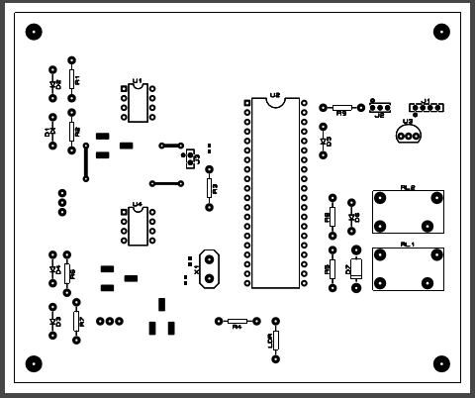

* 1. **Bottom layer ( Image of Copper layer)**

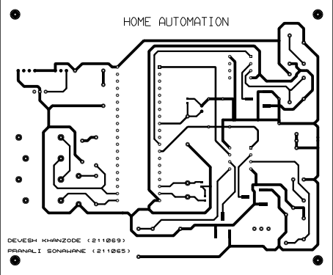

* 1. **3D View**

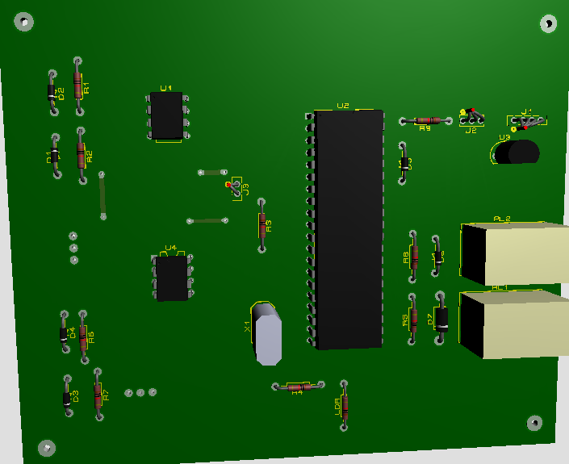

* 1. **PCB information**

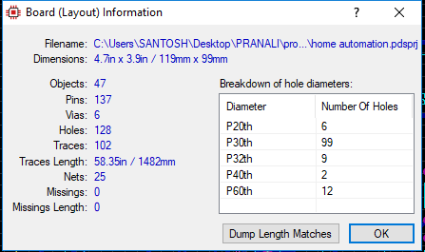

1. **PCB Development Process:**
   1. **PCB Etching:**

* Create a PCB design and print it on a photo paper.
* Cut out the design and place the design face down on the copper clad
* Round a iron on the paper till the design is pasted on the pcb
* Remove the paper and tonner can be seen on the copper clad pcb.
* Place this PCB into mixture of water and FeCl3 (Ferric Cloride) for 10 to 20 minutes, In this process copper is completely removed and dissolved into FeCl3

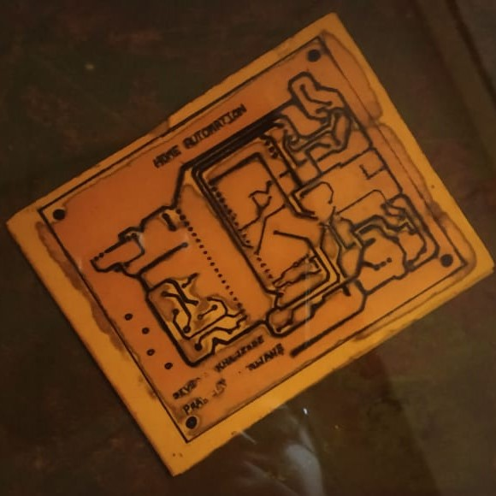

* 1. **PCB Cleaning:**
* Once copper is removed rinse the pcb in water and let it dry.
* Use Rubbing Alcohol or thinner to Whip Off the ink transferred onto the PCB.

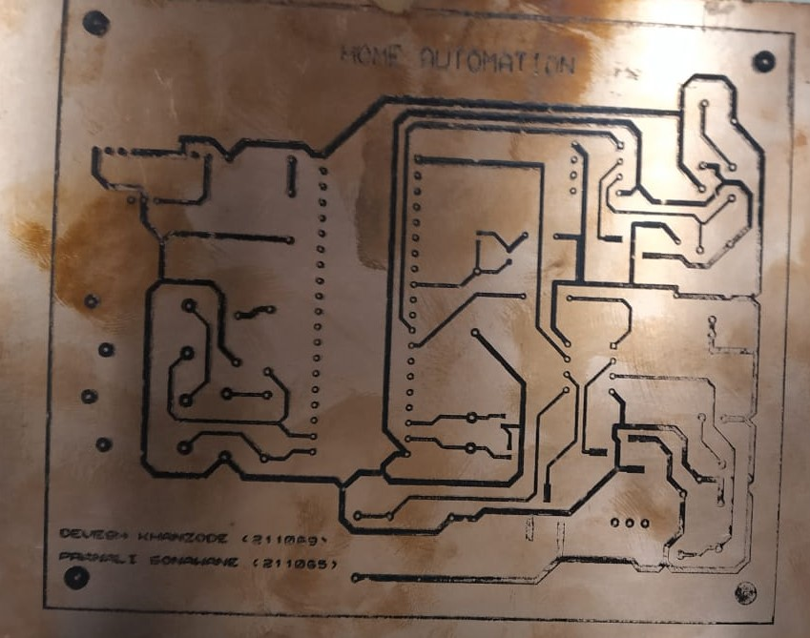

* 1. **PCB Drilling:**
* Place the PCB perpendicular to the drill.
* Use a 1mm drill bit for drilling the holes.

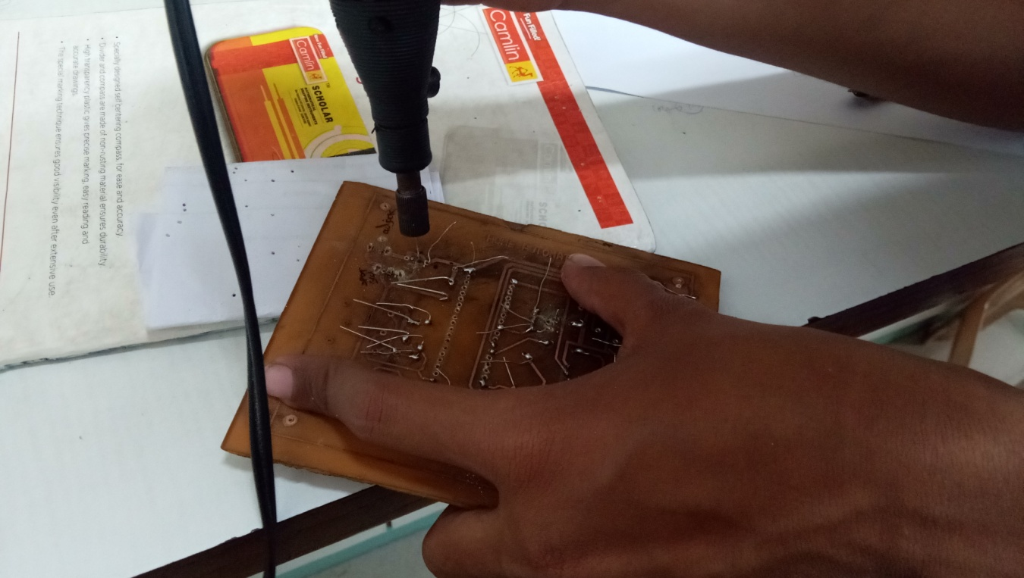

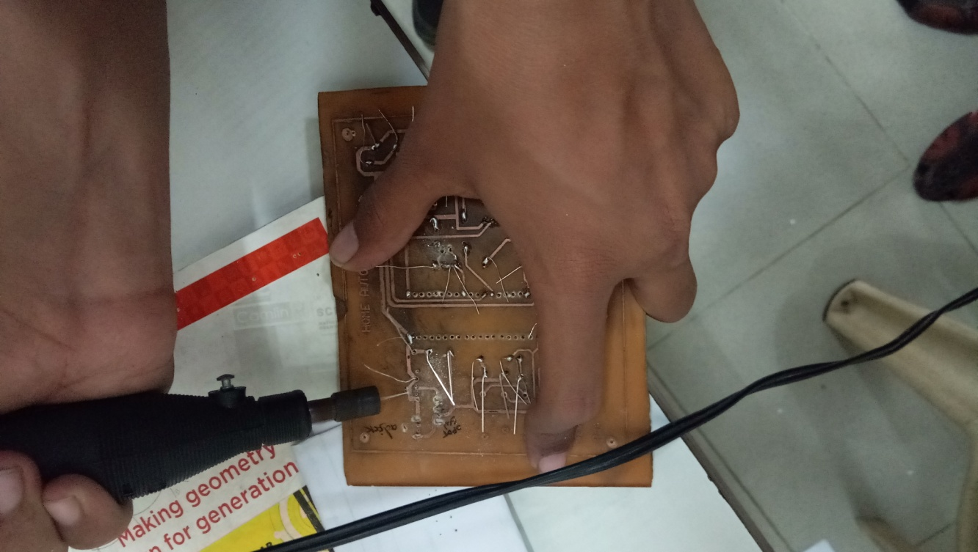

1. **Verification of PCB (Track Continuity checking):**

* We checked the track continuity by using a multimeter.
* We have used HAOYUE DT830D digital multi-meter.

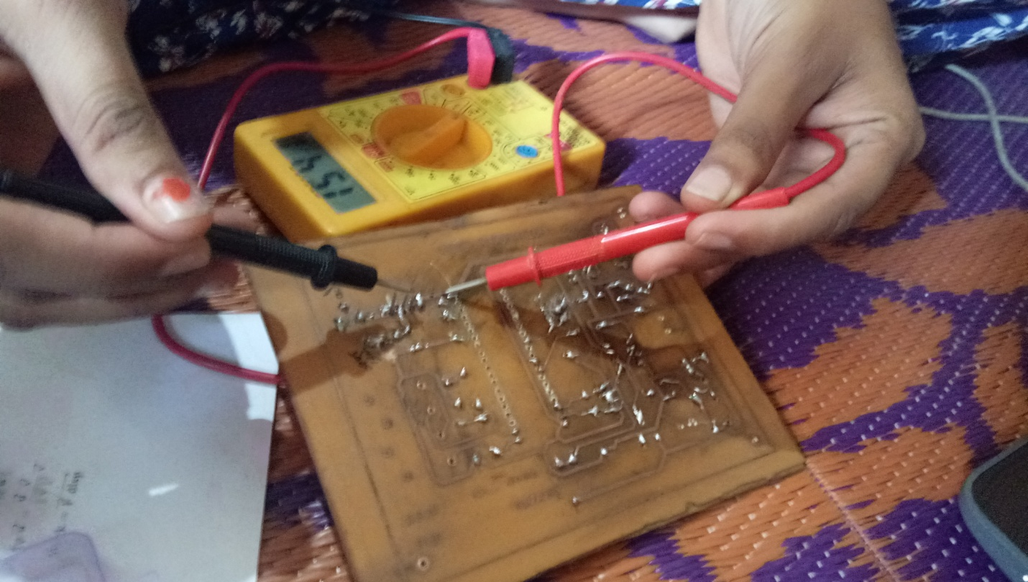

1. 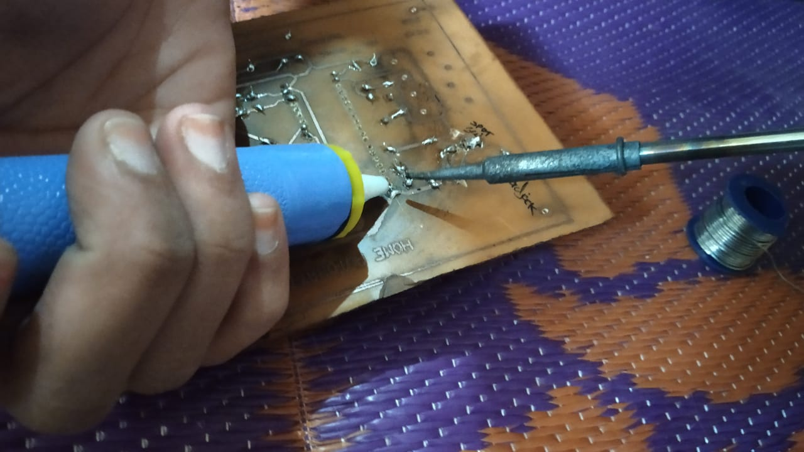**Soldering techniques/Processes**

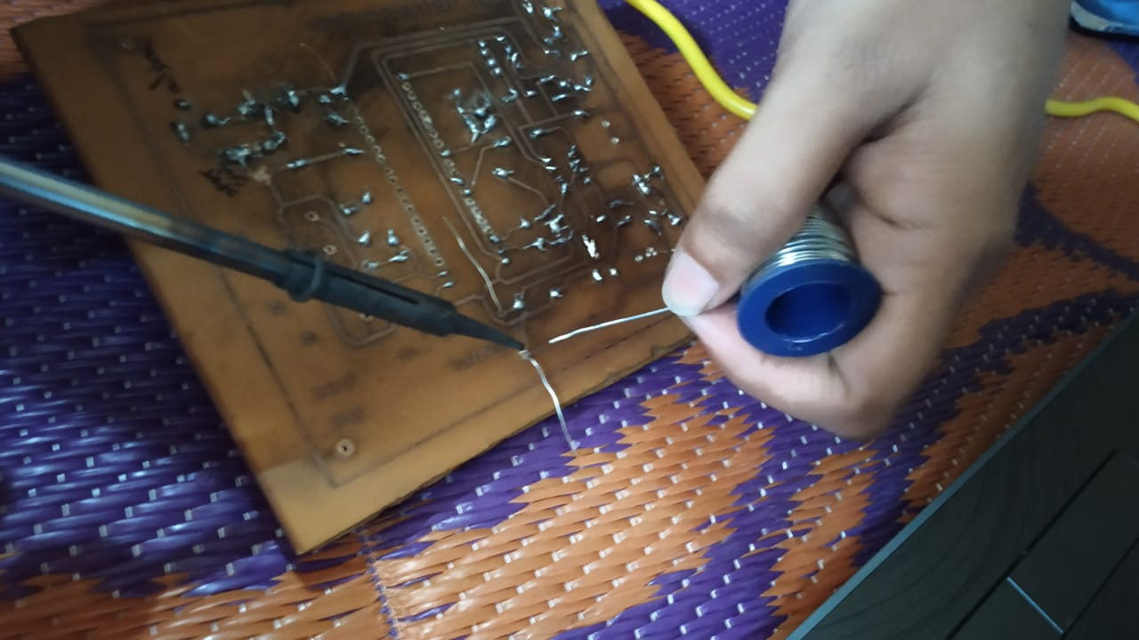

1. **Troubleshooting**

**For troubleshooting purpose multimeter, CRO, power supply can be used.**

**We used a multimeter to check the components, track continuity.**

1. **Actual Hardware Images**
   1. **Solder side ( Copper layer side):**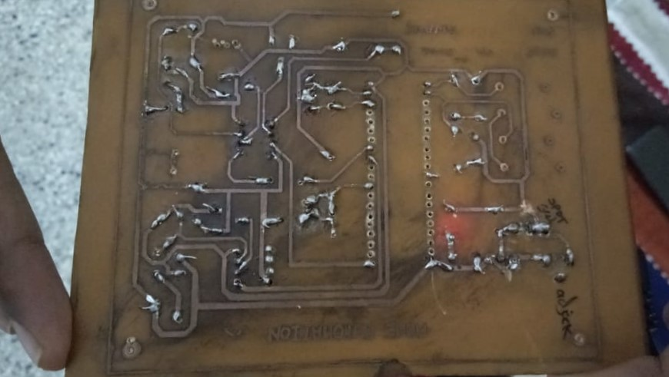
   2. **Component side**

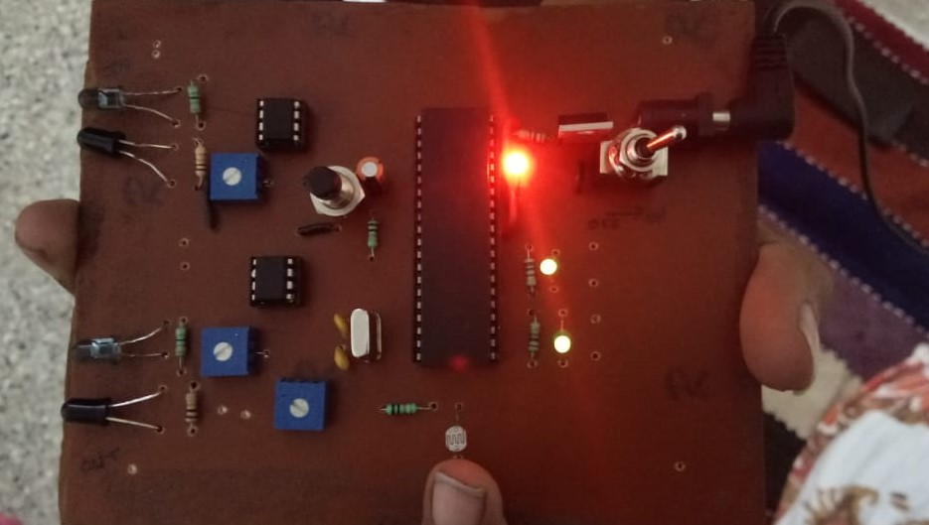

1. **Conclusion**

Home Automation using IR, Photodiode & LDR based light intensity is more effective in case of cost, manpower and security. Home Automation can be used in place of the day to day life appliances reduce the wastage of power and thereby saving energy. This saved power can be used in some other cases. Therefore by using this basic principle we can develop an automatic appliances control system and save the energy for the future use and we can control the losses of the power.

***References***

<http://www.wikipedia.com>

[https://electronicsforu.com/](https://www.google.com/url?sa=t&rct=j&q=&esrc=s&source=web&cd=1&cad=rja&uact=8&ved=2ahUKEwi-zLyZionfAhWCA3IKHR1YDZcQFjAAegQIBBAC&url=https%3A%2F%2Felectronicsforu.com%2F&usg=AOvVaw3mFv58cIYr1p08nLZ8vf-l)